|  |  |
| --- | --- |
|  | **Technical Data Sheet No.6**  **Sealing and Curing of Pavement Layers in Road Construction using Bitumen Emulsion**  Revised by the Association’s Technical Committee – August 2025 |

1. **Introduction**

Bitumen emulsion may be used to provide a water resistant membrane of bitumen to seal road-bases, sub-bases and sub-grades and so prevent ingress of water or water loss by surface evaporation.  This maintains the moisture equilibrium and therefore the strength of the construction course and reduces the loss of fines from the surface by heavy rainfall.  It enables cement bound materials to cure to optimal strength whilst reducing surface crazing and when applied as a surface dressing, it will function as a running surface as well as a seal.  It will also prevent displacement of stone from the surface of bituminous road materials and when applied in between the layers of road construction, particularly as a surface dressing, it will prevent water ingress below the water table.

**2. Formation Sealing**

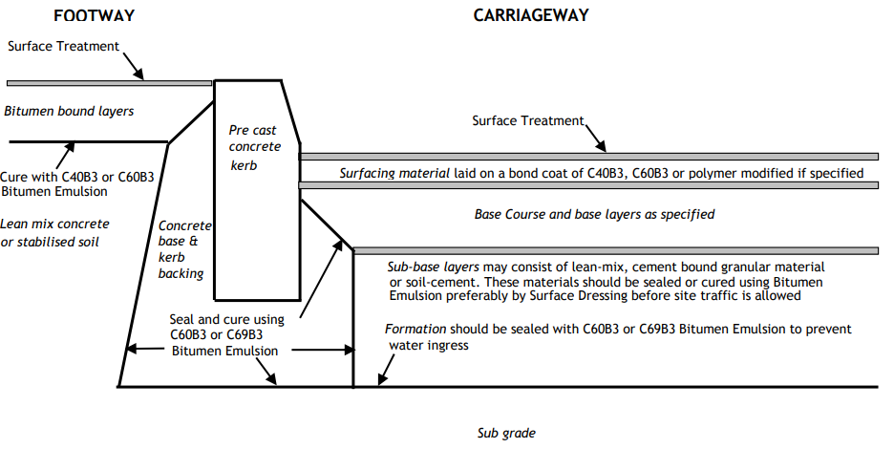

Formations freshly cut for new road construction contain an optimum moisture content which yields a stable condition.  However, two situations can arise which lead to de-stabilisation of the material.

**2.1 Water Ingress**

As new construction is often started in the winter months, rainfall is a problem and site traffic is needlessly held up by boggy conditions.  Use of a surface dressing as a seal can enable work such as embankment and bridge construction to continue in spite of the adverse weather.

**2.2 Water Loss**

Sometimes the formation is cut in hot conditions which lead to evaporation of the moisture from the surface and it may be necessary to dampen the surface to optimise the water content.  Surface dressing is intended to minimise this loss and the use of lightly coloured aggregates reduces the absorption of heat from the sun’s rays.

**3. Recommendations for Formation Sealing**

Freshly cut formation should be dense and free from any loose material and sealed as soon as possible.  The bitumen emulsions used should be fast breaking emulsions such as C60B3 or C69B3.

**4. Non Trafficked Areas**

For areas that will carry no construction traffic between sealing and laying of the next pavement course, a single application of bitumen emulsion at a rate of spread between 1.3 l/m2 and 1.8 l/m2 should be used, depending on the nature of the surface and the bitumen content of the emulsion (see note (i)).  The emulsion should be allowed to break, turning from brown to black.  The surface may then be blinded with dust at 2-4 kg/m2.

**5. Medium Trafficked Areas**

Where light construction vehicles will operate over the sealed formation, a single surface dressing is recommended.  In this case the higher bitumen content emulsions are recommended at a rate of spread between 1.4 l/m2 and 1.8 l/m2, depending on the class of emulsion and texture of the surface (see note (i)). Clean, 2/6mm crushed rock or slag aggregate conforming to EN 13043 [1], should be used at a rate of spread of 6-8 kg/m2 and applied before the emulsion has broken followed by light rolling (for gravel aggregate see note (ii)).

**6. Heavily Trafficked Areas**

Where construction traffic is likely to be heavy, a double surface dressing is recommended.  The use of cement to increase the strength of the sub-grade may be desirable (see Section 8 below).  High bitumen content emulsions are preferred for the surface dressings and the rate of spread for the first dressing should be not less than 0.9 l/m² (suitable for a dense close textured surface). 2/6mm crushed rock or slag chippings conforming to EN13043 [1] should be applied as soon as possible at 6-8 kg/m² and lightly rolled. Excess chippings should be removed and the process repeated using 0.9-1.2 l/m2 (depending on the grade of emulsion) and 2/6mm chippings.  Alternatively, 4/10mm chippings may be used for the second dressing at 9-11 kg/m2 and the rate of spread of emulsion should then be increased by 0.2 l/m2 (for gravel aggregate see note(ii)).

**Note (i) *Rate of Spread*** -When the surface is open textured or porous or under trees, the rate of spread chosen should tend towards the higher limit. In these conditions a high bitumen content emulsion is preferred.  When the surface is dense and closed textured, the rate of spread chosen should tend towards the lower limit. The rates should also reflect the bitumen content of the emulsion used.  For example, when sealing a formation of normal texture which is to take medium traffic, C60B3 bitumen emulsion could be used at a rate of spread of 1.6 l/m2 followed by the application of 6mm chippings.  If it is required to change the emulsion to hot applied C69B3 then the rate of spread should be reduced to 1.4 l/m2.

**Note (ii) *Gravel Chippings*** -Where gravel chippings are used the rates of spread of emulsion recommended above must be increased by 0.2 l/m2.

**7. Sealing of Wet Mix and Other Water Bound Materials**

Water-bound sub-base such as wet mix material depends largely upon an optimum moisture content for strength and it is therefore important to seal the surface as soon as possible after laying and compacting. The same rates of application and types of emulsion as recommended for formation sealing are applicable. The use of a surface dressing is strongly recommended as it reduces the risk of damage to the surface and temperature effects.

**8. Sealing of Cement Bound Bases, Sub-Bases and Lean Mix Concrete**

The curing of cement stabilised materials is extremely important in order to obtain the maximum designed strengths. The surface should be sealed as soon as possible after compaction, preferably within one hour of laying. Emulsion class C60B3 is normally used although lower bitumen content emulsions such as C40B3 may sometimes be permitted on uniform, close textured surfaces. A rate of spread between 1.0 l/m2 and 1.5 l/m2 should be used depending on the bitumen content of the emulsion and the film should be allowed to break. This is then blinded with dust at 2-4 kg/m2. The use of a surface dressing is recommended as this decreases the possibility of damage to the seal.  Where heavy site traffic is to be allowed on the cured material, a double dressing is recommended. The same specifications as detailed in the section on surface dressing of formations may be used.

**9. Curing In-situ Cement Stabilised Soil**

The in-situ stabilisation of soils involves spreading a measured amount of cement on the surface of the material to be stabilised, mixing it with water, rolling, and then sealing the surface with bitumen emulsion.  It is possible to up-grade a wide range of materials quite dramatically and very economically by this method.  The bitumen emulsion seals the surface thereby maintaining the moisture equilibrium of the stabilised layer and enabling it to reach its maximum strength.

**10. Kerb Sealing**

The concrete backing to kerb stones may be cured with bitumen emulsion.  Emulsion can be used to seal around the base of the kerbs as shown in the diagram to reduce the ingress of water at the interface of the kerb and the pavement course.  Bitumen emulsion may be applied liberally as it will act as a joint sealant. Special proprietary emulsions intended for use as joint sealants are available.

**11. Bond Coating**

Bond coats should always be applied between asphalt, macadam courses and bases.  Further information is available in Technical Data Sheet No. 5 - Bond Coating

**12. Surface Dressing**

Surface dressing as a method of providing a non-skid surface to both the footway and the carriageway is well documented in Road Note 39 [2] and Technical Data Sheet No. 4.  However, there remains a large potential for surface dressing as part of the design in new construction, for example, directly to the Base Course or on High Stone Content Asphalt.  This maximises resistance to deformation and enhances the skid resistance and macro-texture.  C69B3 bitumen emulsion is a particularly suitable binder for this purpose.  If the site is a high stress or high speed area, then a polymer modified emulsion would be more appropriate.

**13. Footways**

When surface dressing footways, C60B3 and C69B3 are recommended.  Full information on surface dressing footways is given in Technical Data Sheet No. 7.

**14. Curing of Pavement Quality Concrete**

Bitumen emulsions are suitable for curing pavement quality concrete.  The emulsions should be class C40B3 or C60B3, the 40% grade normally being preferred.  Class A-1 anionic emulsions to BS 434-1 can also be used. Within one hour of laying the concrete, it should be given a coating of emulsion at a rate of spread 0.5 l/m2 to 0.9 l/m2 depending on the grade of emulsion and surface texture, followed soon after by the application of sand or small grit. The road may be opened to traffic as soon as the concrete has attained the required strength as specified by design.

**15. Sealing of Hot Rolled Asphalt or Macadam Base Course**

In new road construction, especially on large housing or industrial estates, the base course may be left open for a period before the overlaying with a wearing course.  A surface dressing or slurry surfacing is an effective method of sealing the course in the interim.

**16. Practical Techniques for Sealing and Curing**

It is important to agree the most suitable method of treatment at the tendering stage, so that the correct equipment is used and provision made for the best practicable job.

**16.1 Emulsion Binder**

Owing to the nature of the work it is probable that only small areas will be sealed at any one time.  This may mean that the use of bulk distributors will be impracticable and that a spraying unit using a small motorised sprayer or hand operated equipment is the most appropriate method of application.  This is necessary when the strength of the base or formation is insufficient to take the weight of a bulk distributor.

The seal is effective provided that a continuous film of binder is formed over the surface.  To achieve an even application when working with a hand lance, the emulsion should be sprayed with a circular action rather than a side-to-side swing. When drums are used they should be set out at estimated intervals along the carriageway corresponding to the desired rate of spread.

**16.2 Chippings**

It is probable that chipping spreaders, although preferred, may not be used on many surfaces because of their weight, so small lorries or barrows will prove more convenient to place small chipping stockpiles along the site.  The chippings used for surface dressing should comply with EN13043 [1].  For the final dressing it is important to ensure that the binder is well covered with chippings so that it is not picked up on vehicle tyres.

**16.3 Rolling**

When surface dressing, rolling should be carried out immediately after the chippings have been applied preferably using a pneumatic tyred roller.

**16.4 Drums of Binder**

Drums must be rolled vigorously at prescribed intervals (see Technical Data Sheet No. 2 - Recommendations for the Safe Handling and Storage of Bitumen Road Emulsions.)during storage and before use.  Drums must be protected from frost.

**16.5 Bulk Emulsion Binder**

When the bitumen emulsion is stored in a mobile bulk storage tank, or used through a bulk distributor, it should be circulated thoroughly before starting work.  When using emulsion binders, reference should be made to the REA Code of Good Practice for the Use and Safety of Mobile Storage Tanks.

**17. Health and Safety**

The manufacturer’s Health and Safety Information should be followed.  Reference should be made to Technical Data Sheet No. 2 - Recommendations for the Safe Handling and Storage of Bitumen Road Emulsions.

**18. Equipment**

After use clean equipment following the advice in REA Technical Data Sheet No 3 ‘Recommendations for the Cleaning and Maintenance of Spraying Machines for use with Bitumen Emulsion’.

**19.** **UKCA/CE Marking**

At the end of June 2013, the Construction Products Regulation (CPR) was fully implemented in all EU member states. Since then, Construction products covered by a harmonised European standard (EN) have a legal requirement to be CE marked in order to place them on the European market. The UK withdrew from the European Union in January 2020 and in January 2021 introduced its own UKCA mark. A transition period for implementation of the UKCA mark was introduced but this period has been extended indefinitely meaning that both CE and UKCA Marking can continue to be used.

***References***

[1] BS EN 13043:2002 Aggregates for bituminous mixtures and surface treatments for roads, airfields and other trafficked areas

[2] Road Note 39: Design Guide for Road Surface Dressing – published by Transport Research Laboratory

**For further information on all REA Technical Data sheets please look on the “Technical Datasheets” webpage on** [**www.rea.org.uk**](http://www.rea.org.uk/)

*Whilst every care is taken to ensure the accuracy of the general advice offered herein by the Road Emulsion Association, no liability or responsibility of any kind can be accepted by the Association.*